**Physiotherapy website**

**1. Model Selection:**

For your Physiotherapy website project, I am using the Prototyping Process Model with the Three-Tier Architecture (MVC design pattern). This combination allows for iterative development and accommodates evolving requirements, while also providing a structured and scalable application design. It ensures better maintainability and flexibility throughout the development process.

**2. Reason for Selection:**

The MVC model is a widely-used architectural pattern that separates the concerns of an application into distinct components, making it easier to manage and maintain the codebase.

**Prototyping Process Model:**

* Supports evolving requirements.
* Involves stakeholders for feedback and insights.
* Helps identify and mitigate risks early.

**Three-Tier Architecture (MVC) Design Pattern:**

* Promotes modularity and reusability.
* Enhances scalability and maintainability.
* Provides flexibility for user interface updates.

**Combining Prototyping and MVC:**

* Enables iterative development.
* Fosters a user-centric approach.
* Adapts to changing requirements effectively.

In summary, the combination of Prototyping and MVC ensures a user-focused, adaptable, and maintainable approach to developing the Physiotherapy website.

**3. Requirements:**

Scenario: Physiotherapy Website

**1. Homepage**

* + Display a welcoming and informative landing page with an appealing design.
  + Present a clear navigation menu to guide users to different sections of the website.
  + Provide a brief introduction to the physiotherapy clinic's services and expertise.
  + Include contact information (phone number, email) for inquiries and appointments.

**2. About Us**

* + Feature a detailed "About Us" section describing the clinic's history, mission, and values.
  + Introduce the physiotherapy team with brief profiles and their qualifications.
  + Highlight any certifications, awards, or affiliations that showcase the clinic's credibility.

**3. Services Offered**

* + List various physiotherapy services offered, such as musculoskeletal therapy, sports injury rehabilitation, post-surgical care, etc.
  + For each service, provide a concise description and explain its benefits to potential patients.
  + Mention any specialized treatments or innovative approaches unique to the clinic.

**4. Appointment Booking**

* + Offer an easy-to-use online appointment booking system for patients.
  + Provide a calendar with available time slots for each physiotherapist.
  + Allow users to select their preferred date and time and submit appointment requests.

**5. Patient Testimonials**

* + Display genuine testimonials from satisfied patients to build trust and credibility.
  + Include photos and names (with consent) to add authenticity to the testimonials.
  + Consider showcasing success stories of patients who have achieved significant recovery.

**6. Blog / News Section**

* + Incorporate a blog or news section to share informative articles and physiotherapy-related updates.
  + Publish content on injury prevention, exercise tips, and general wellness advice.
  + Encourage user engagement through comments and social media sharing.

**7. Frequently Asked Questions (FAQ)**

* + Create an FAQ page addressing common questions and concerns of potential patients.
  + Cover topics related to treatment duration, insurance coverage, clinic facilities, etc.
  + Provide accurate and concise answers to facilitate quick information retrieval.

**8. Contact Us**

* + Offer a comprehensive contact form for general inquiries and feedback.
  + Provide a Google Maps integration to display the clinic's location and directions.
  + Include the clinic's physical address, phone number, and email for alternative communication.

**9. Responsive Design**

* + Ensure the website is fully responsive, adapting to various devices and screen sizes.
  + Optimize loading times to prevent user frustration and improve SEO ranking.

**10. Accessibility**

* + Comply with accessibility standards (WCAG) to cater to users with disabilities.
  + Implement alt text for images, keyboard navigation, and easy-to-read font sizes.

**11. Social Media Integration**

* + Include links to the clinic's social media profiles (Facebook, Instagram, etc.).
  + Allow users to share website content on their social media platforms.

**12. Privacy Policy and Disclaimer**

* + Display a clear and transparent privacy policy to inform users about data collection and usage.
  + Provide a disclaimer for medical advice, emphasizing the need for professional consultation.

**13. Security Measures**

* + Implement SSL encryption to secure user data during online interactions.
  + Regularly update and maintain website security protocols to protect against potential threats.

**14. Multilingual Support**

- Consider offering multilingual support to cater to a diverse audience.

- Provide language options for major languages spoken in the target region.

**15. Site Search Functionality**

* + Incorporate a search bar to facilitate easy navigation and content discovery.
  + Allow users to quickly find specific information or services they are interested in.

These requirements aim to create an effective, user-friendly, and informative one-page Physiotherapy website that meets the needs of patients seeking reliable information and appointment booking convenience.

**4. Diagrams:**

**a) Sequence Diagram:**

**Appointment Service**

**Physiotherapist**

**Patient**

Request available physiotherapists and services

**Patient selects Physiotherapist Service**

Return list of available physiotherapists and services

Schedule Appointment (selectedPhysiotherapist, selectedService, date, time

CheckAvailability (selectedPhysiotherapists, date, time

[Physiotherapist available]

Available

Appointment Scheduled successfully

[Physiotherapist not-available]

Appointment Booking failed

Not-available

**Appointment Service**

**Physiotherapist**

**Patient**

1. The Patient initiates the process by requesting available physiotherapists and services from the AppointmentService.
2. The AppointmentService responds by providing a list of available physiotherapists and services.
3. The Patient selects a specific Physiotherapist and a Service for the appointment.
4. The Patient then requests to schedule an appointment with the chosen Physiotherapist, Service, and desired date and time.
5. The AppointmentService checks the availability of the selected Physiotherapist for the given date and time.
6. If the Physiotherapist is available, the AppointmentService confirms the appointment booking, and the successful message is sent back to the Patient.
7. If the Physiotherapist is not available, the AppointmentService informs the Patient about the unavailability, and the appointment booking fails.

**b) Activity Diagram:**

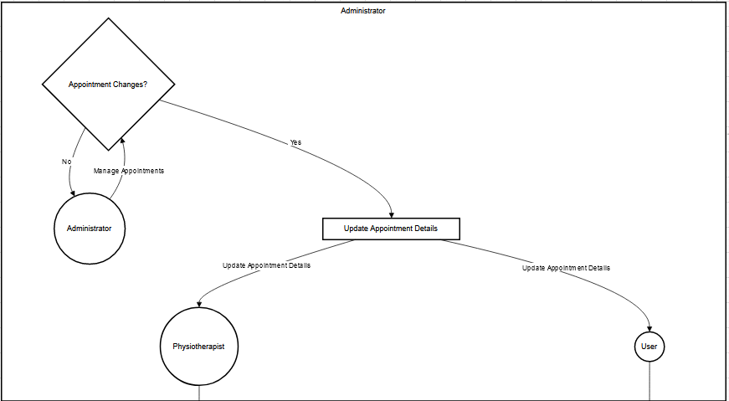

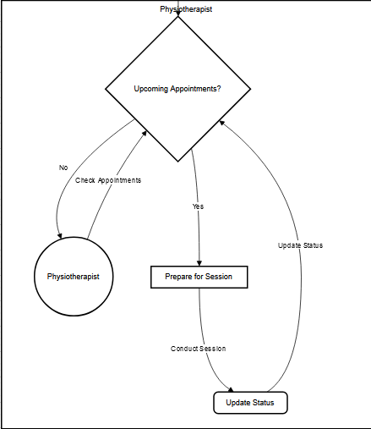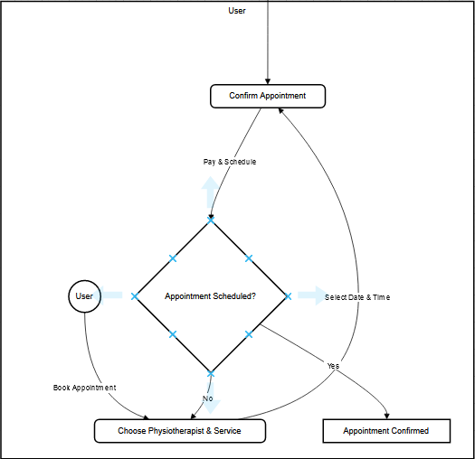

* **User** (represented by User) can initiate the process by **Booking an Appointment**. They then **Choose a Physiotherapist & Service**, **Select a Date & Time**, and finally **Confirm the Appointment** by paying and scheduling it. If the appointment is successfully scheduled (Appointment Scheduled?), the process ends with the appointment being Confirmed.
* **Physiotherapist** (represented by Physiotherapist) can **Check Upcoming Appointments** they are assigned to. If there are upcoming appointments (Upcoming Appointments?), they prepare for the session and later Conduct the Session. After the session, they Update the Status of the appointment, and the process loops back to checking for upcoming appointments.
* **Administrator** (represented by Administrator) can **Manage Appointments**, including handling any changes (Appointment Changes?). If there are changes, they Update Appointment Details, which can involve assigning a new physiotherapist (Physiotherapist) or notifying the user (User) of the updated details. After updating the appointment details, the process loops back to managing appointments.

**c) State Diagram:**

Appointment Scheduled

Scheduled

Canceled Appointment

Appointment Reschedule

Reschedule Appointment

Appointment Completed

Canceled

Rescheduled

Completed

Appointment Canceled

* The initial state is represented by [*], indicating that the appointment starts in the "Scheduled" state.
* The "Scheduled" state represents an appointment that is booked and confirmed.
* From the "Scheduled" state, the appointment can transition to three different states based on specific events:
  + "Canceled": The appointment is canceled by the patient or clinic.
  + "Completed": The appointment is marked as completed after the physiotherapy session is done.
  + "Rescheduled": The appointment is rescheduled to a different date or time.
* Once an appointment is canceled or completed, it transitions back to the initial state, represented by [*], indicating that the appointment process has ended.

**d) Swim-line Diagram:**

Administrator

Administrator

Manage Services

Management Service

Physiotherapist

Physiotherapist

Manage Users

Manage Appointment

User

Update Appointment Status

Check Appointment

User

View Appointment

Book Appointment

Appointment Service

* We use the graph directive to create the swim-lane diagram.
* The swim-lanes represent different actors or departments: **User**, **Physiotherapist**, and **Administrator**.
* The boxes within the swim-lanes represent the actions performed by each actor or department.
* The arrows represent the interaction between the actors and the **Appointment Service**, **Service Management**, and **User Service** (which handle the interactions related to appointments, services, and users, respectively).

**e) Class Diagram:**

**Physiotherapist**

**Patient**

+ PhysiotherapistID : Integer

+ FirstName : String

+ LastName : String

+ Gender : String

+ ContactNumber : String

+ Email : String

+ Specialization : String

+ PatientID : Integer

+ FirstName : String

+ LastName : String

+ Gender : String

+ DateOfBirth : Date

+ ContactNumber : String

+ Email : String

+ Address : String

**Service**

+ ServiceID : Integer

+ ServiceName : String

+ Description : String

+ Duration : Integer

+ Price : Decimal

**\***

**\***

**Appointment**

+ AppointmentID : Integer

+ Date : Date

+ Time : Time

+ Status : String

+ Notes : String

**\***

* This class diagram with four classes: Patient, Physiotherapist, Appointment, and Service. Each class includes its attributes, represented by their names and data types.
* The relationships between the classes are depicted using the arrows (-->). The Patient, Physiotherapist, and Service classes have a one-to-many relationship with the Appointment class, indicated by the asterisk (*) on the Appointment side of the arrows.